**DC POSITION CONTROL**

**OBJECT**

To study the performance characteristics of a D.C. motor angular position control system.

**EQUIPMENT DESCRIPTION**

A major position of any first course on automatic control system invariably revolves mound the study of D.C. position control system. Experimental work in this area has however been confined to analog simulated system, e.g. through our 'Linear System Simulator' or similar other units. The biggest advantage of this approach is the unlimited flexibility and near perfect operation of the simulated systems leading to a close correlation between theoretical and experimental results, however, the student is denied the feel of a physical electro-mechanical system. The present unit has been designed with this objective in mind. Despite the constraints like friction, dead zone, nonlinearities due to amplifier saturation and motor current limiting, and low speed of response associated with any mechanical system, the student has been provided with enough opportunity for experimentation on a working system. The panel diagram in Fig. 1 shows the various built-in subsystems which are now described.

**Signal Sources**

*Angle command (continuous):* obtained through a potentiometer with a calibrated Disk attached.

*Angle command (step):* available through a toggle switch. Automatic synchronization with waveform capture circuit is provided.

**Motor Unit**

The position control is achieved through a good quality permanent magnet D.C. gear Motor. The specifications of the motor are:

* Operating voltage: 24Vdc
* No load current : 0.16A
* Full load current : 2.8A
* Rated speed : 40 rpm
* Torque (basic) : 1.48 Kg-cm

However, in DCP-OI we are using this motor at only 12Vdc.

Angular position of the motorShaft is sensed by a special 360° rotation potentiometer attached to it. A calibrated disk mounted on the potentiometer indicates its angular position in degrees. In addition to this, a small tachogenerator attached voltage proportional to its speed, which is used for feedback. To the motor shaft produces a All the above components, viz. the motor, potentiometer, tachogenerator etc. are fitted Inside the 'motor unit'. Transparent panels provide a good view of the interior. The motor unit is connected to the rest of the system through a 9-pin D-type connector and cables.

**MAIN UNIT**

The main unit houses the command circuit the door detector, the gain controls of the forward path and tachogenerator channels, the power stage and the waveform capture/display unit. Different experiments are performed by appropriate settings of the controls as explained Inter. Description of the above blocks is given next.

**(a) Command:**

Two operating modes have been provided in the system.When a continuous command is given by the rotation of potentiometer through a certain angle, the closed loop system responds by an identical rotation of the motor shaft. Alternatively, step command equivalent to about 150 degrees may be given by switch. This is used for quantitative studies of the step response.

**(b) Error detector:**

This is a 4-input 1-output block. Two of the inputs are meant for command signals and the remaining two inputs, having 180° phase shift, are used for position and velocity feedback signals.

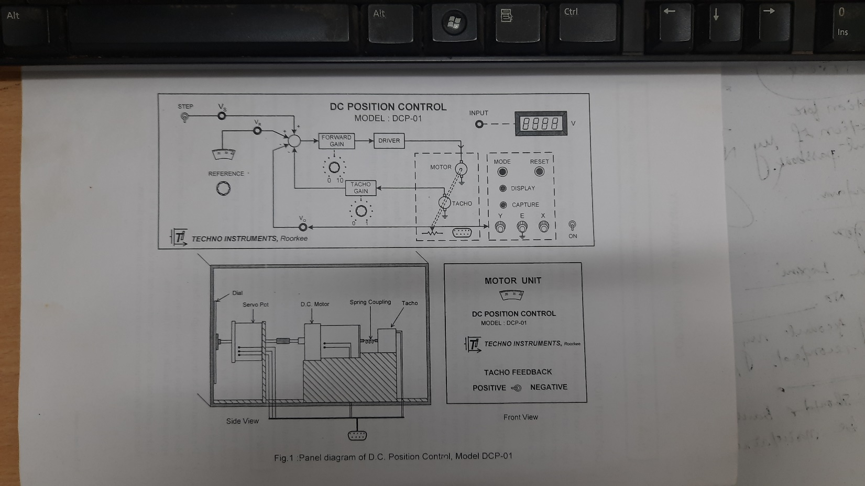

**FIG.1: PANEL DIAGRAM OF D.C. POSITION CONTROL, MODEL DCP 1**

**(c) Gain blocks:**

The forward path gain is adjustable from 0 to 10 and the tachogenerator channel gain may be varied from 0 to 1. The gains may be read from the markings on the panel.

**(d) Driver:**

The driver is a unity gain complementary symmetry power amplifier suitable for running the motor up to full power in either direction. A current limiting circuit ensures safety of the power transistors during motor starting and direction reversal.

**(e)Waveform Capture/Display unit:**

The time response of a mechanical system like the present one is usually too slow for a CRO display, except on a storage oscilloscope. Alternatively an X-Y recorder could be used to get a hard copy which may subsequently be studied quantitatively. Both these options are quite expensive for a usual undergraduate laboratory. The waveform capture/display unit is a microprocessor based card which can ‘capture’ the motor response and then ‘display' the same on any. Ordinary X-Y oscilloscope for a detailed study. The stored waveform is erased whenever another waveform is captured, or the unit is reset.

**Power Supply**

The set-up has a number of IC regulated supplies which are permanently connected to all the circuits. No external D.C. supply should be connected to the unit. Capabilities of this unit include an evaluation of the performance of the position control system for different values of forward gains. Also the effect of tachogenerator feedback on system stability forms an important study. Effect of non-linearity, so common in all practical systems, may be readily observed by the student. In all the cases the response is stored and can then be displayed on an ordinary measuring oscilloscope.

**Position Control - a second order system a second order system is represented in the standard form as,**

$G\left(s\right)=\frac{ω_{n}^{2}}{s^{2}+2ζω_{n}s+ω_{n}^{2}}$

Where $ζ$ is called the damping ratio and $ω_{n}$ the un-damped natural frequency. Depending upon the value of G, the poles of the system may be real, repeated or complex conjugate which is reflected in the nature of its step response. Results obtained for various cases are:

**(a) Underdamped case $(0<ζ<1)$**

$c\left(t\right)=1-\left(\frac{e^{ζω_{n}t}}{\sqrt{1-ζ^{2}}}\right)sin({ω_{d}t+\tan^{-1}{\sqrt{\frac{1-ζ^{2}}{ζ}}}}$…………………………………………………………… (1)

Where, $ω_{d}=ω_{n}\sqrt{1-ζ^{2}}$ is termed the damped natural frequency. A sketch of the unit step response for various values of $ζ$ is available in the text books.

**(b) Critically damped case $(ζ=1)$**

$c\left(t\right)=1-e^{ω_{n}t}(1+ω_{n})$……………………………………………………………………………………………. (2)

**(c) Overdamped case $(ζ>1)$**

$\left(t\right)=1-\frac{ω_{n}}{2\sqrt{1-ζ^{2}}}\left(\frac{e^{-s_{1}t}}{s_{1}}-\frac{e^{-s_{2}t}}{s_{2}}\right)$………………………………………………………………………………… (3)

Where $s_{1}=\left(ζ+\sqrt{(ζ^{2}-1}\right)ω_{n} and s_{2}=\left(ζ-\sqrt{(ζ^{2}-1}\right)ω_{n}$

Referring to Fig. 2, the transfer function G(s) of an armature controlled D.C. motor may be derived as,

$$\frac{θ\left(s\right)}{E\left(s\right)}=G\left(s\right)=\frac{K_{m}}{s\left(sT+1\right)}$$

Where, $K_{M}$ is Motor gain constant, and T the Mechanical time constant.

Considering proportional feedback only, the close loop transfer function of the system of Fig. 3 may be obtained as.

$$\frac{C\left(s\right)}{R\left(s\right)}=\frac{K_{A}G\left(s\right)}{1+K_{A}G\left(s\right)}=\frac{\frac{K_{A}K_{m}}{T}}{s^{2}+\frac{s}{T}+\frac{K_{A}K_{m}}{T}}$$

This gives unit step response similar to equations (1), (2), or (3) depending upon the value of ${ K}_{A}$. Thus the response of the position control system can be altered by varying the amplifier gain $K_{A}$, and a 'satisfactory' performance may usually be obtained. This leads to the concept of performance characteristics as defined on the step response of an underdamped second order system in Fig. 4 and explained in brief here.

1. **Delay time**, $t_{d},$ is defined as the time needed for the response to reach 50% of the final value.
2. **Rise time**, $t_{r,}$ is the time taken for the response to reach 100% of the final value for the first time. This is given by

$t_{r}=\frac{π-β}{ω_{d}}$, where $β=\tan^{-1}{\sqrt{\frac{1-ζ^{2}}{ζ}}}$

1. **Peak time**, $t_{p}$ is the time taken for the response to reach the first peak of the overshoot and is given by $t_{p}=\frac{π}{ω_{n}\sqrt{1-ζ^{2}}}$
2. **Maximum overshoot**, $M_{P}$ is defined by

$M_{P}=\frac{c\left(t_{p}\right)-c\left(∞\right)}{c\left(∞\right)}×100\%$

**Settling time, $t_{s}$** , is the time required by the system response to reach and stay within a prescribed tolerance band which is usually taken as +2% or +5%. An approximate calculation based on the envelops of the response for a low damping ratio system yields.

$$t_{s}\left(±5\% tolerance band\right)=\frac{3}{ζω_{n}}$$

$$t_{s}=\left(±2\% tolerance band\right)=\frac{4}{ζω_{n}}$$

Another important characteristic of a closed loop system is the steady state error, $e_{ss}$, unity feedback systems $e_{ss}$ is defined as

$e_{ss}={}_{t→∞}^{lim}{e\left(t\right)={}_{t→∞}^{lim}{\left\{r\left(t\right)-c(t)\right\}}}$

A simpler way to calculate steady state error without actually computing the time response is available in the complex frequency domain. Application of the final value theorem of Laplace Transform to unity feedback system gives,

$e_{ss}=\lim_{t→∞}{e(t)}=\lim_{s→0}{sE(s)}=\lim_{s→0}{\frac{sR\left(s\right)}{1+G\left(s\right)}}$

Steady state error may be obtained for various inputs (step, ramp, parabolic) and systems of various type numbers (number of poles at origin).To facilitate the calculations, error coefficients are defined as

* Position error coefficient, $k_{A}={}_{s→0}^{lim}{ G(s)}$
* Velocity error coefficient, $k_{V}={}_{s→0}^{lim}{ sG(s)}$
* Acceleration error coefficient, $k_{a}={}_{s→0}^{lim}{ s^{2}G(s)}$

***The position control system has a second order transfer function in the standard form.***

***The system should not have any steady state error for step input.***

***The transient response of the system is affected by the value of $K_{A}$. A higher value of $K_{A}$ should result in larger overshoot.***

**Tachogenerator feedback**

It maybe intuitively obvious that availability of a single adjustable parameter K in the position control system is likely to meet only one of the performance characteristics. In most cases however one is interested in at least two specifications simultaneously e.g. steady state error and the damping factor or peak overshoot. In an electromechanical system this is conveniently achieved through a tachogenerator feedback.

Considering the tachogenerator feedback path also active in Fig. 3, the closed loop transfer function is obtained as

$\frac{C\left(s\right)}{R\left(s\right)}=\frac{K_{A}G\left(s\right)}{1+K_{A}G\left(s\right)\left(1+K_{D^{s}}\right)}=\frac{\frac{K_{A}K_{m}}{T}}{S^{2}+\left(1+K_{A}K_{m}K_{D}\right)\left(\frac{s}{T}\right)+\frac{K_{A}K_{m}}{T}}$

It is easily seen that the steady state error to unit ramp is given by

$e_{ss}=1/K_{A}K_{m}$, and the damping ratio by

$ζ=(1+K_{A}K_{m}K_{D})/2\sqrt{TK_{A}K_{D}}$

**Thus the specification of $e_{ss}$, and $ζ$ may be met simultaneously by a proper choice of $K_{A}$ and $K_{D}$.**

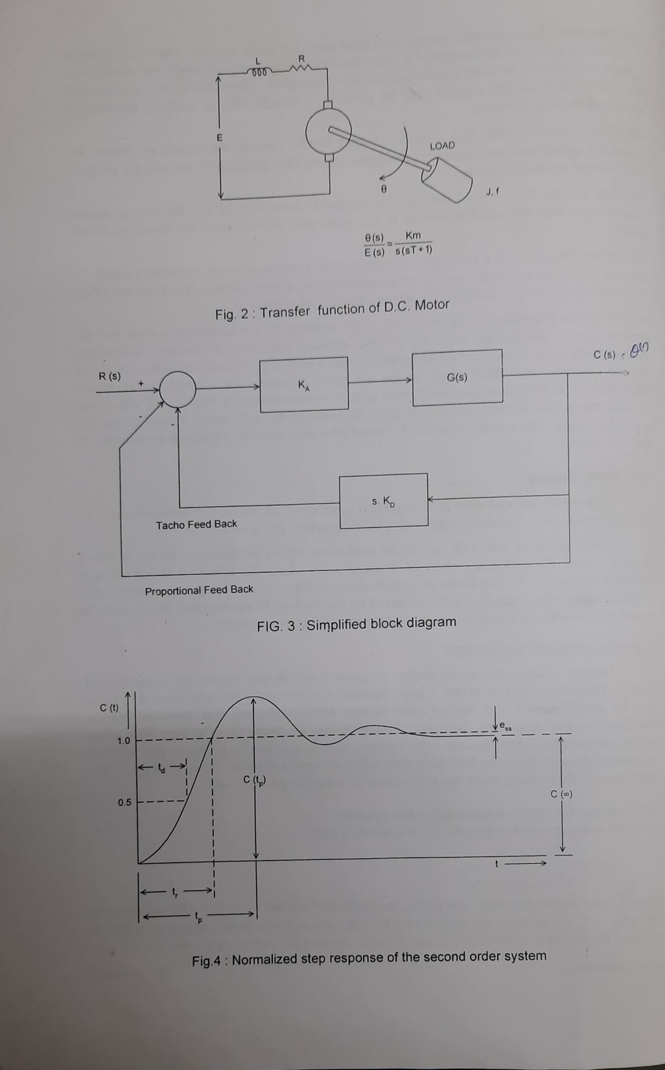

**FIG.2: TRANSFER FUNCTION OF D.C. MOTOR**

**System Imperfections**

All practical systems are imperfect to some extent. As a result of this, the actual system response differs from the ideal response of Fig. 4, which is valid for a second order linear system. Some of the contributing factors relevant to the present set-up are:

* **Saturation of armature current** – necessary to protect the driver from high currents when the motor starts or reverses its direction. This implies limiting the maximum control effort for large errors leading to a slower response.
* **Amplifier saturation** - has effects similar to above although the saturation is now a circuit limitation.
* **Dead zone -** caused by a minimum voltage below which the motor would not start due to the friction of the brushes and bearings. As a result of this the steady state error may be larger than expected.
* **Nonlinear tachogenerator and motor characteristics** - due to manufacturing inaccuracies.
* **System order** - may be actually more than two, due to load characteristics, delays and filters used.
* *An accurate analysis taking into account the above mentioned imperfections would certainly prove to be exceedingly complex. The experiments which follow therefore consider the system as it is, study the response and the effect of tachogenerator feedback on the response. A qualitative comparison of the result of experiment with the theoretical predictions for a second order linear system should be of great interest.*

**EXPERIMENTAL WORK**

The experiments suggested below enable the reader to study the performance of the closed loop system with proportional feedback and closed loop system with combined proportional and techogenerator feedback. Idea of dead zone and its effect on steady state error is also introduced. A special provision has been made in the set-up to store and display a response of the system -a need which occurs quite frequently.



**FIG.3: SIMPLIFIED BLOCK DIAGRAM**

**FIG.4: NORMALIZED STEP RESPONSEOF THE SECOND ORDER SYSTEM**

**WAVEFORM CAPTURE/DISPLAY**

This card is designed to automatically store the response of the system in a RAM Whenever a step input is given. The stored response is then displayed on the CRO. Steps for its operation are as given below:

* Power ON the system and/or press the RESET switch- unit goes into DISPLAY the axes and shows the RAM contents (zero at present).
* Press the MODE switch- the unit becomes ready to capture the step response.
* Applying step input now starts the storage. At the end of the capture cycle, the mode automatically shifts to DISPLAY and the response waveform is seen on the CRO.
* Storage of a new response or pressing the RESET switch erases the current waveform.
* The time scale of the display may be calibrated by feeding the X-output (saw tooth) of the unit to the Y-input of the CRO and determining its time period and amplitude.

**CLOSED LOOP STUDY (ALSO SEE THE NOTE AT END)**

**Position control through CONTINUOUS command**

* Ensure that the step command switch is OFF.
* Starting from one end, move the COMMAND potentiometer in small steps and observe the rotation of the response potentiometer.
* Record and plot $θ_{R}, V_{R}, θ_{0}$ and $V_{0}$ for a few values of $K_{A}$.
* Calculate ${∆θ}_{R},$ and ${∆θ}_{0}$ (taking initial readings as nominal values) and plot. Also calculate the errors (${∆θ}_{R}-{∆θ}_{0}$), (${∆V}_{R}-{∆V}_{0}$) at each step. Justify the presence of errors and their variation with $K_{A}$.

**Position control through STEP command**

* Ensure that the tachogenerator feedback switch on the MOTOR UNIT is set to NEGATIVE.
* Adjust the reference potentiometer to get $V_{R}$ =0.
* Set $K_{A}$ to 2.
* Connect the CRO, calibrate the time scale, switch to CAPTURE mode.
* Apply STEP input. Wait till storage is complete and the response is displayed. Trace the waveform from CRO.
* Compute $K_{P},$ $ζ, t_{p} and t_{r}$ and the steady state error.
* Repeat for $K_{A}$ = 3,4..... .
* Now set $K_{A}$ =6, and choose various values of $K_{P}$ =0.1, 0.2... and repeat the above observations.
* Tabulate the results as shown in the next section and discuss :
* variation of maximum overshoot, rise time and steady state error with forward gain.
* effect of tachogenerator feedback on maximum overshoot, rise time and stability.
* effect of dead zone and saturation on step response.
* Compare your results with theoretical predictions assuming a second order system.
* A set of observations with POSITIVE tachogenerator feedback may also be taken in the same manner as above.

**TYPICAL RESULTS**

Typical results obtained on a similar unit are next given for guidance. The reading and result have all been obtained using the waveform capture and other built-in facilities of the unit.

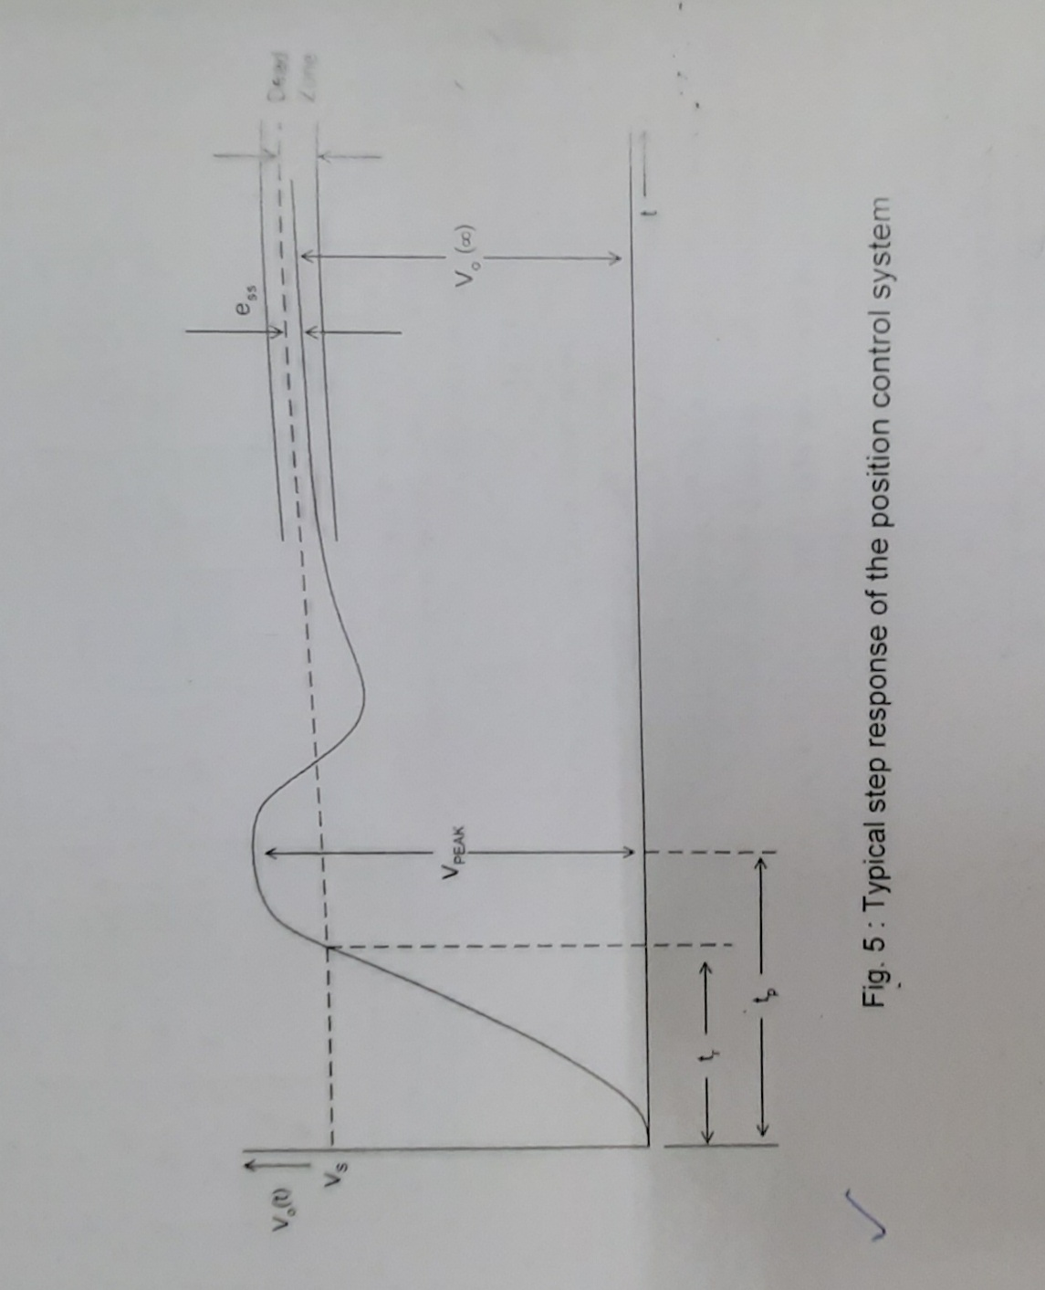

**FIG.5: TYPICAL STEP RESPONSE OF THE POSITION CONTROL SYSTEM**

**Manual operation of the position control**

$K_{D}$ = 0, $K_{A}$ =5 Tachogenerator channel disabled

|  |  |  |  |  |  |  |  |  |
| --- | --- | --- | --- | --- | --- | --- | --- | --- |
| S. No. | $$θ_{R}$$ $$deg$$ | $${Δθ}_{R}$$ $$deg$$ | $$θ_{0}$$ $$deg$$ | $${Δθ}_{0}$$ $$deg$$ | $${Δθ}_{R}-{Δθ}_{0}$$ $$deg$$ | $$V_{R}$$ $$Volt$$ | $$V_{0}$$ $$Volt$$ | $${ΔV}_{R}-{ΔV}_{0}$$ $$Volt$$ |
| 1  2  3  .  .  .  . | 0  30  60  90 | -  30  60  90 | 5  31  62  95 | -  26  57  90 | -  4  3  0 | 0  0.20  0.87  1.43 | 0  0.13  0.90  1.48 | 0  0.07  -0.03  -0.05 |

***The measured values of VR have negative signs which have not been inverted in the internal circuitry for technical reasons. These may however be read as positive and calculation should be made with positive values*.**

**Calibration of X-output**

* In the DISPLAY mode with X-output connected to the Y-input of CRO, a saw tooth waveform is seen. On measurement,
* Amplitude of saw tooth = 5.6 volts.
* Time duration of the main linear part = 39 msec.
* X-output scale factor is thus 6.96 msec/volt
* The X-output waveform above consists of axis display part and waveform display part. The latter is identified by a much longer time duration which has been measured above.

**Step response of the position control without tachogenerator feedback**

* Set $K_{D}$ =0 ,
* $V_{s}$ =2.5 V (internally set)

|  |  |  |  |  |  |  |  |
| --- | --- | --- | --- | --- | --- | --- | --- |
| S. No. | $$K_{A}$$ | $$M_{P}\%$$ | $$t_{P}$$ $$msec$$ | $$t_{r}$$ $$msec$$ | $$ζ$$ | $$e_{ss}$$ | $$ω_{n}$$ $$rad/sec$$ |
| 1  2  3  .  .  .. | 5  7 | 16.8  20.8 | 10.5  6.96 | 4.2  3.48 | 0.493  0.447 | 0.12  0.0 | 343.9  504.6 |

* Referring to Fig. 5,
$e_{ss}=V_{s}-V_{0}, where V_{S} and V_{0} may be measured by DVM$

$M_{P}=\frac{V_{PEAK}-V_{0}\left(∞\right)}{V_{0}\left(∞\right)}×100\%$

* $t_{P},$ $t_{r}$ may be obtained from CRO
* $ζ$ may be calculated from $M_{P}$ using the standard relation
$$M_{P}=\exp\left(-\frac{πζ}{\sqrt{\left(1-ζ^{2}\right)}}\right)$$

* $ω_{n}$ is calculated from the expression of $t_{p}\left\{=π/ω_{n}\sqrt{(1-ζ^{2})}\right\}$
* The closed loop and open loop transfer functions of the system may now be written as, Closed loop : $\frac{{ ω}_{n}^{2}}{s^{2}+2ζω_{n}s+ω_{n}^{2}}=\frac{2.54×{10}^{5}}{s^{2}+4.51×{10}^{5}s+2.54×{10}^{5}}$
* Open loop (excluding $K_{A})$: $\frac{1}{K_{A}}\frac{ω_{n}^{2}}{s\left(s+2ζω_{n}s\right)}=\frac{2.54×{10}^{5}}{7×s\left(s+4.51×{10}^{2}s\right)}$

***The open loop transfer function (excluding $K_{A}$) comes out to be different for different readings - the system is not actually a second order function.***

***The peaks of the response curves are flattened - the motor has dead zone.***

***The peak overshoot does not increase significantly with $K_{A}$- motor armature Currents is restricted.***

**Step response of the position control with tachogenerator feedback**

* $K_{A}$**=7, $V_{s}$ =2.5 volts (internally set)**

|  |  |  |  |  |  |  |  |
| --- | --- | --- | --- | --- | --- | --- | --- |
| S. No. | $$K_{P}$$ | $$M_{P}\%$$ | $$t_{P}$$ $$msec$$ | $$t_{r}$$ $$msec$$ | $$ζ$$ | $$e_{ss}$$ $$volt$$ | $$ω_{n}rad/sec$$ |
| 1  2  3  .  .  . | 0  0.1  0.2 | 20.80  12.44  0 | 6.96  8.10  - | 3.48  4.17  5.22 | 0.447  0.552  1 | 0.1  0.1  0 | 504.6  465.1  - |

$M_{P}, t_{P}, ζ$ And $e_{ss}$ may be obtained as outlined in (c) above.

***The tachogenerator feedback is seen to reduce increase ¢. Relative stability is improved.***

***There is an increase in $t_{r}$ and $t_{P}$. The system becomes slower.***

***The steady state error remains unchanged.***

**THANK YOU**